Respiratory and Circulatory Revision Booklet

1. Label the diagram of the lungs below

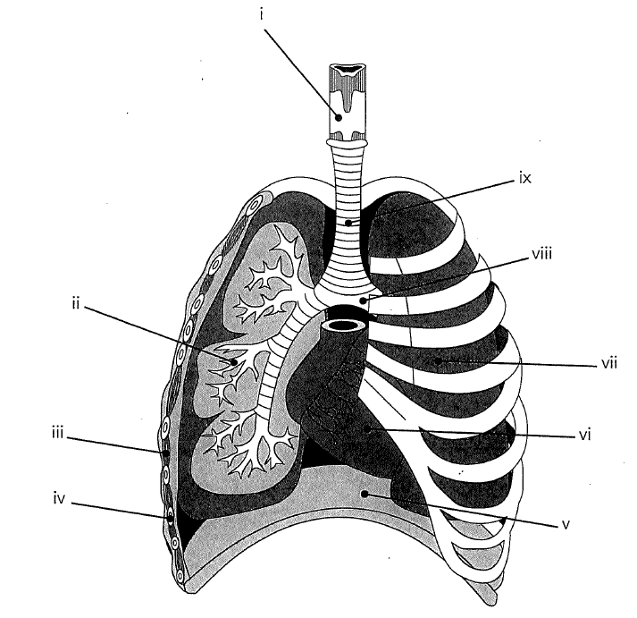

1. For each of the structures listed below explain the function and how its structure is important to its role.
   1. Nasal cavity

* 1. Pharynx

* 1. Larynx

* 1. Trachea

* 1. Lungs

* 1. Bronchi

* 1. Bronchioles

* 1. Alveoli

* 1. Pleural membrane

* 1. Diaphragm

* 1. Intercostal muscles

1. Name and describe the process of bringing air into the lungs

1. Explain expiration, using a diagram to support your answer

1. Ollie the oxygen molecule is breathed in through your nose, explain the path he takes to get into your blood stream.

1. How is the oxygen concentration gradient between the alveoli and the blood in the capillaries maintained

1. What adaptations does the alveolus have to make it more efficient in carrying out its function

# Circulatory system

1. Label the diagram of the heart

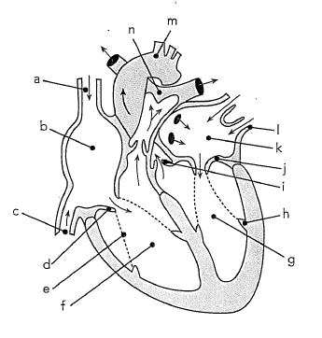

1. Explain why body cells require each of the following
   1. Oxygen:
   2. Glucose:
   3. Minerals:
2. How are the substances from question 9 transported to the body cells

1. Jellyfish do not have a circulatory system. Why do humans and other complex multicellular organisms need one?

1. The diagram below represents the circulatory system, label the diagram
   1. Draw arrows to represent the direction in which the blood flows through the system
   2. Using a red pen shade in the arteries and veins that carry oxygenated blood
   3. Using a blue pen shade in the arteries and veins which carry deoxygenated blood

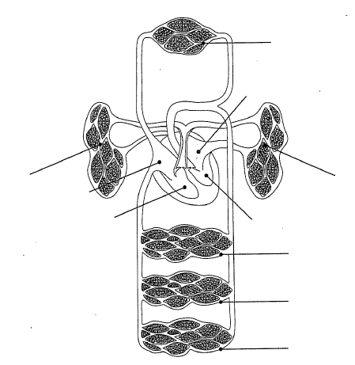

1. Where does blood become deoxygenated

1. Where does blood become oxygenated

1. Which artery carries deoxygenated blood

1. Which vein carries oxygenated blood

1. Explain the difference between systolic and diastolic pressure

1. Explain the difference between pulmonary and systemic circulation

1. Draw a diagram to represent a cross section of an artery, vein and capillary
2. Complete the table

|  |  |  |  |
| --- | --- | --- | --- |
| Feature | Artery | Vein | Capillary |
| Thickness of wall |  |  |  |
| Presence of valves |  |  |  |
| elasticity |  |  |  |

1. How does carbon dioxide travel in blood

1. Complete the table below

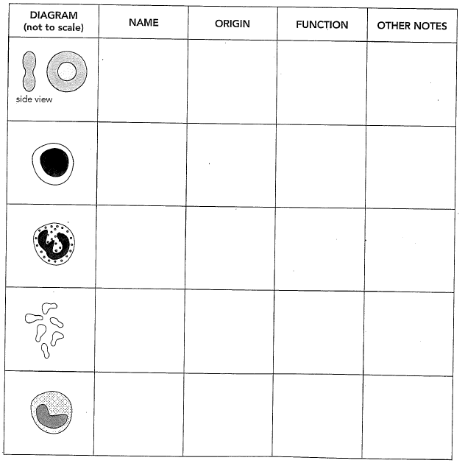

1. Explain the role of platelets